Race Briefing

All Ireland
Post Primary School
Triathlon Championships

Sunday, 19th May 2019

Event Details
Race Name | All Ireland Post Primary School Triathlon Championships
Race Date | Sunday, 19th May 2019
Start Time | 12.30pm
End Time | 3.30pm
Location | Brothers of Charity Centre  Kilcornan  Clarinbridge  Co. Galway  H91 AE7V  GPS 53.231936, -8.861716
Distances | MINOR Under 14  200m Swim / 6.7km Cycle / 1.5m Run  JUNIOR Under 15  300m Swim / 6.7km Cycle / 2km Run  Intermediate Under 17  300m Swim / 9km Cycle / 2.5km Run  Senior Under 19  400m Swim / 12km Cycle / 3.2km Run

Race Director: Tony Daley

Event Timetable | Date | Time | Venue/Location
Registration Opens | 19th May | 11.00am -12.00pm | The Lair, Predator Triathlon Clubhouse. Kilcornan  GPS 53.231936, -8.861716
Registration Closes | 19th May | 12.00pm | The Lair, Predator Triathlon Clubhouse. Kilcornan
Marshal/Stewards briefing | 19th May | 12.00pm | Kilcornan Swim Complex
Competitor Race Briefing | 19th May | 12.15pm | Kilcornan Swim Complex
Event Start | 19th May | 12.30pm | Kilcornan Swim Complex

Registration Notes:
Registration will take place in the Lair, 300m from Kilcornan Swim Complex from 11.00am-12.00pm. (GPS 53.231936, -8.861716).
All athletes - regardless of their wave time must attend registration during this time.
Each athlete will be given their number, timing chip and be body marked.
Each athlete must go straight to transition following registration.

Swim Notes:
The swim takes place in 20 metre pool. The maximum water depth is 1.5 metres.
There is one wave for each of the four age groups.
Under 14 200m Swim / 10 laps
Under 15 300m Swim / 15 laps
Under 17 300m Swim / 15 laps
Under 19 400m Swim / 20 laps
The first wave will begin at 12.30pm with under 19’s and once they have finished their swim the under 17’s will start their swim. The 2nd wave will start at approximately 1pm with under 15’s followed by under 14’s as soon as under 15’s finish their bike leg. Five pool lanes will be available with a maximum of five athletes per lane. You must be present on time to start in your designated lane and time.
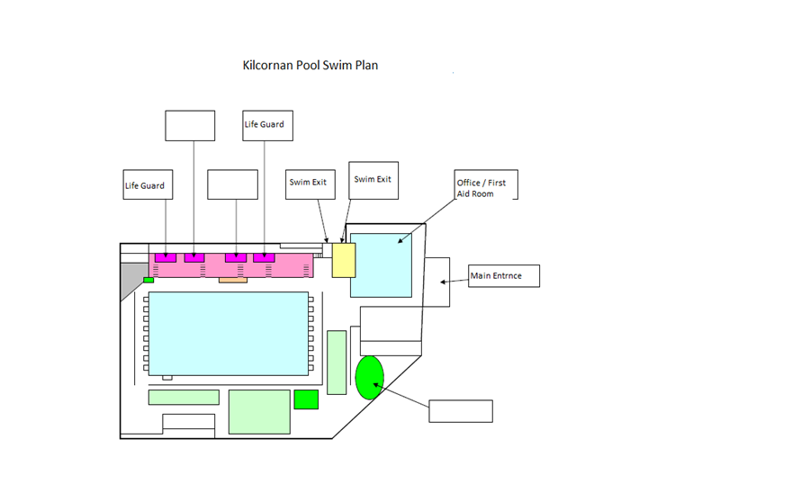
Figure 1 Swimming Pool layout

Transition Notes:
The transition will be positioned directly outside the swim exit door. A one-way system will be in place and strict guidelines will be applied to transition rules and regulations. During registration each athlete will be informed of their designated transition area to rack their bike. Please ensure you rack your bike in the correct area as your bike may be moved if in the incorrect area.
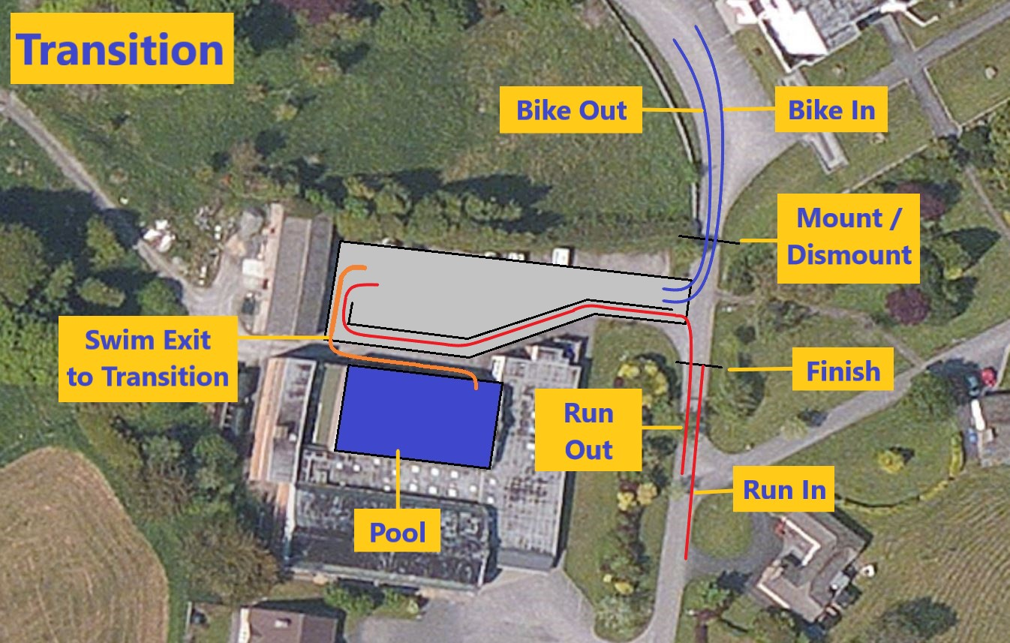
Figure 2 Transition Area
Bike Notes:
Important Bike Rules
All age categories will be draft-legal.
The following equipment restrictions will apply for ALL athletes competing in all age categories at this event.
1. The following bicycle types are ALLOWED:
a. road bike – must be used in Intermediate and Senior Championship
b. hybrid bike
c. mountain bike
d. youth style bike
2. The following bicycle types are NOT ALLOWED:
a. time trial style bike
b. recumbent style bike
c. BMX bike
3. Only standard drop, straight, or curved handlebars are allowed:
No aero or time trial bars may be attached to the bike or used during competition. This includes “Factory Bridged Clip On Bars” normally allowed under the ITU Competition Rules.
4. All wheels used in competition, with the exception of mountain bikes, hybrid bikes and youth style bikes, must have the following characteristics:
a. Both wheels must be of equal diameter
b. Wheels shall have at least 16 metal spokes
c. Spokes can be round, flattened or oval, provided their width does not exceed 2.4mm
d. The maximum rim dimension will be 25mm on each side
5. No disc wheels or wheel covers are allowed.
6. Tubular Tyres, if used, must be well glued, the levers of the quick releases must be closed tightly into the hubs and wheels must be properly fixed to the frame.
7. Time trial style helmets may NOT be used.

Minor/Junior Bike Course
The Minor (U14) and Junior (U15) will complete a two looped course of 6.7km distance on estate grounds. Competitors will turn at the lodge and return to the arch where they will turn and return to the lodge. Once they have turned at the lodge they will return into transition.

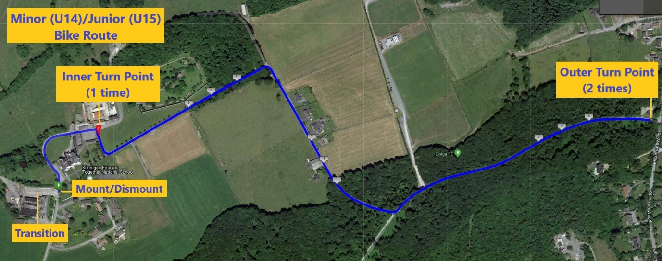

Figure 4 Minor Bike Course

Intermediate (U17) /Senior (U19) Bike Course
These two age categories will complete their bike leg on an out and back loop of 9k and 12km respectively on OPEN roads.
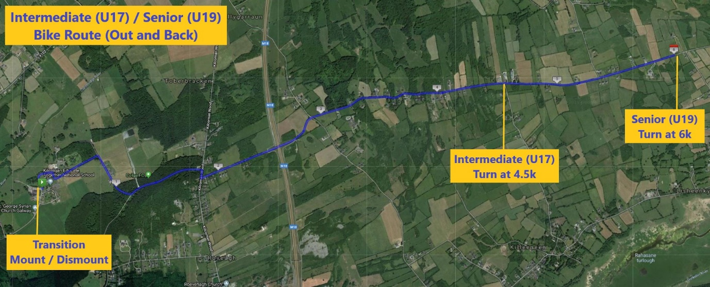
Figure 6 Intermediate/Senior Bike Course
Normal rules of the road apply.

Run Notes
The run for Minor (U14), Junior (U15) and Intermediate (U17) age categories will be run fully on a tarmac out and back course. The Senior (U19) run route will involve a section of Forest Trails but mostly be on tarmac roads.
The finish will be at transition.
Under 14 1.5km Run - turn at 750m point back to finish.
Under 15 2km Run- turn at 1k point back to finish.
Under 17 2.5km Run - turn at 1250m point, turn back to finish.
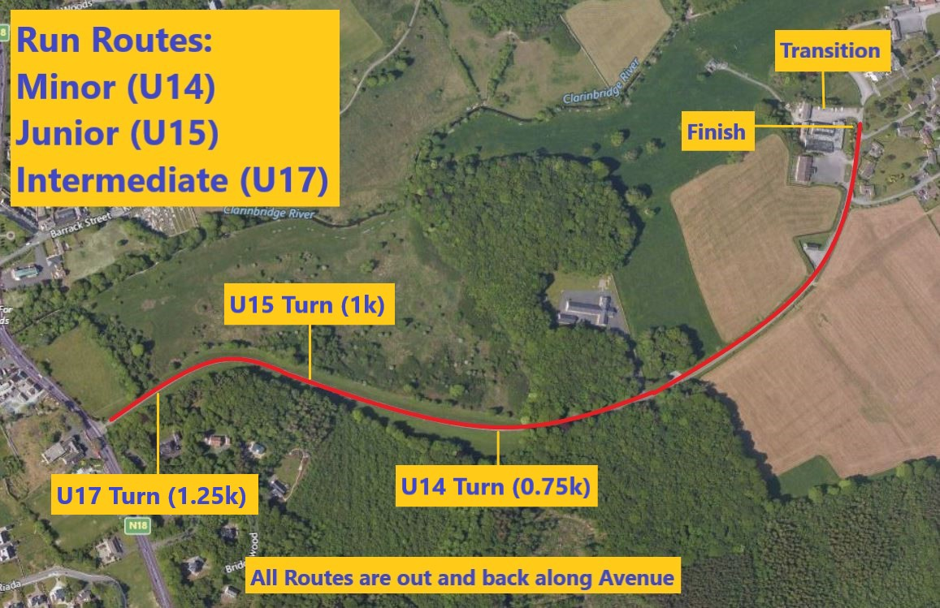
Figure 7 - U14 U15 U17 Run Routes.

U19 – 3.25k run – Run down avenue, turn Left into the Forest, then right in the forest onto the Main fire road, then right onto the hard shoulder of the main road, then right again in the main Kilcornan entrance and back up the avenue to the Finish Line.
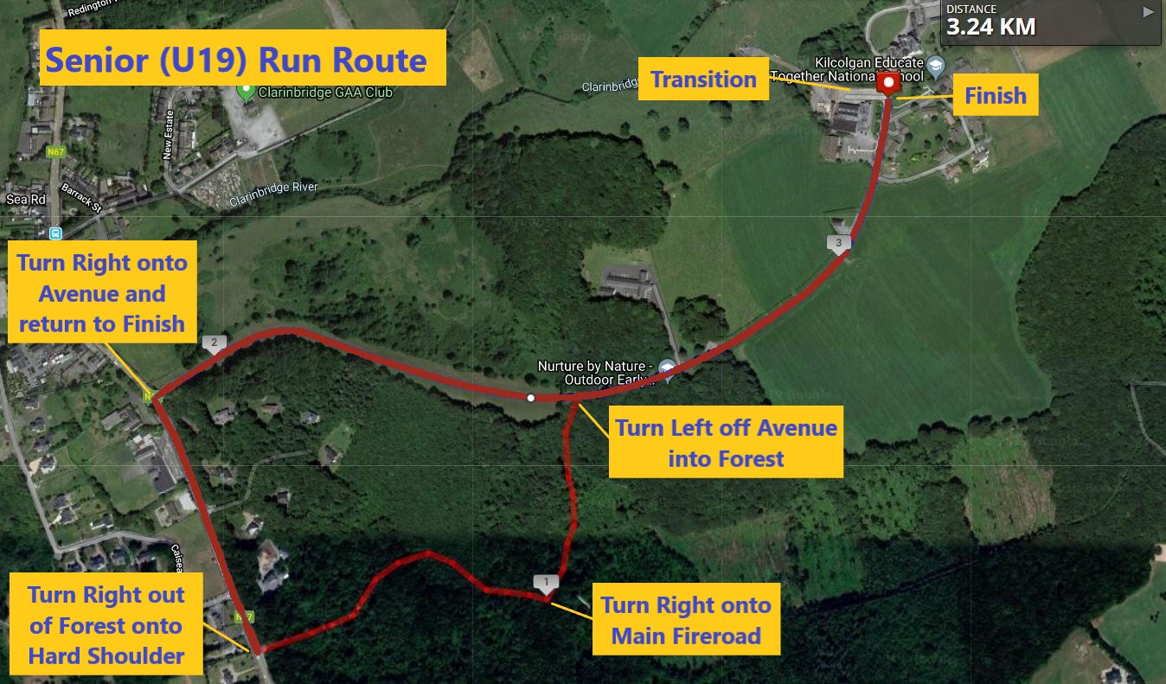
Figure 8 - U19 Run Route.

Results
This event is chip timed. There will be presentation of prizes after the finish of the last race.
The first 3 boys and girls in each age group will be awarded medals.

End

